CEE 691—001 Homework #5
Shibo Wang
14.1 Solution:
Table 13.1
v,m/s | 10 | 20 | 30 | 40 | 50 | 60 | 70 | 80
F,N | 25 | 70 | 380 | 550 | 610 | 1220 | 830 | 1450
Least square procedure:
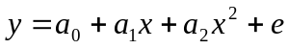
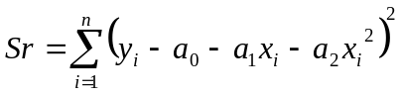
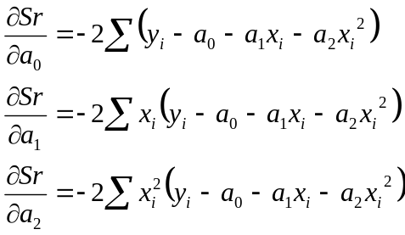
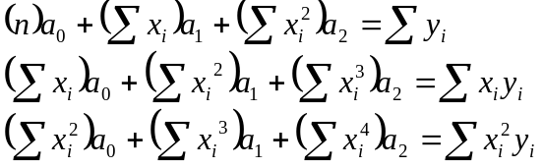

Computations for an error analysis of the quadratic least-squares fit
x_{i} | y_{i} | (y_{i}-)² | 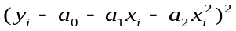
10 | 25 | 380534.8 | 7203.731675
20 | 70 | 327041.0156 | 11334.54071
30 | 380 | 68578.51563 | 8882.534708
40 | 550 | 8441.015625 | 12601.90347
50 | 610 | 1016.015625 | 503.1407886
60 | 1220 | 334228.5156 | 122626.1725
70 | 830 | 35391.01563 | 102341.6403
80 | 1450 | 653066.0156 | 515.1901248
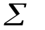 | 5135 | 1808296.875 | 266008.8543
m=2 n=8 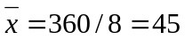 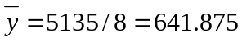
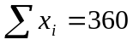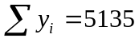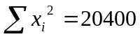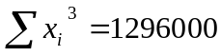
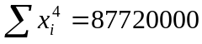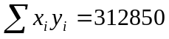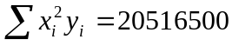
Run Matlab to solve a₀, a₁, a₂
>> N=[8 360 20400; 360 20400 1296000; 20400 129600 87720000]
N =
8 360 20400
360 20400 1296000
20400 129600 87720000
>> r=[5135; 312850; 20516500]
r =
5135
312850
20516500
>> a=N\r
a =
-178.4821
16.1220
0.0372
Therefore, a₀= -178.4821, a₁= 16.1220, a₂= 0.0372
The least-square quadratic equation for this case is
Since 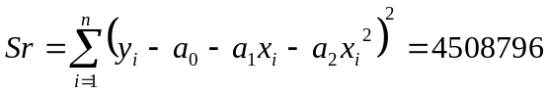
The standard error of the estimate based on the regression polynomial is
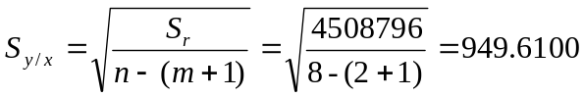
Since 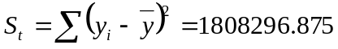
Therefore, the coefficient of determinatinon r² should be:
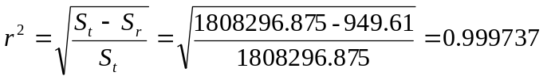or
the correlation coefficient 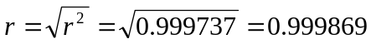
This result shows that after polynomial regression, the accuracy of the approximation has been greatly improved.

14.6 Solution:
According to Table 14.5
Dissolved oxygen concentration in water as a function of temperature and concentration of Chloride (g/L)
T,ºC | c=0 g/L | c=10 g/L | c=20 g/L
0 | 14.6 | 12.9 | 11.4
5 | 12.8 | 11.3 | 10.3
10 | 11.3 | 10.1 | 8.96
15 | 10.1 | 9.03 | 8.08
20 | 9.09 | 8.17 | 7.35
25 | 8.26 | 7.46 | 6.73
30 | 7.56 | 6.85 | 6.20
Least square procedure: Multiple linear regression
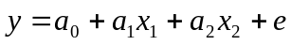
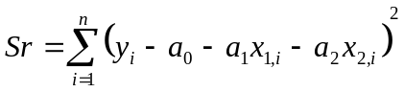
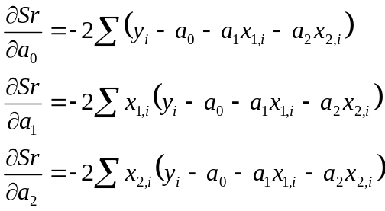
x_{1,i} | x_{2,i} | y_{i} | x₁² | x₂² | x₁x₂ | x₁y | x₂y
0 | 0 | 14.6 | 0 | 0 | 0 | 0 | 0
0 | 10 | 12.9 | 0 | 100 | 0 | 0 | 129
0 | 20 | 11.4 | 0 | 400 | 0 | 0 | 228
5 | 0 | 12.8 | 25 | 0 | 0 | 64 | 0
5 | 10 | 11.3 | 25 | 100 | 50 | 56.5 | 113
5 | 20 | 10.3 | 25 | 400 | 100 | 51.5 | 206
10 | 0 | 11.3 | 100 | 0 | 0 | 113 | 0
10 | 10 | 10.1 | 100 | 100 | 100 | 101 | 101
10 | 20 | 8.96 | 100 | 400 | 200 | 89.6 | 179.2
15 | 0 | 10.1 | 225 | 0 | 0 | 151.5 | 0
15 | 10 | 9.03 | 225 | 100 | 150 | 135.45 | 90.3
15 | 20 | 8.08 | 225 | 400 | 300 | 121.2 | 161.6
20 | 0 | 9.09 | 400 | 0 | 0 | 181.8 | 0
20 | 10 | 8.17 | 400 | 100 | 200 | 163.4 | 81.7
20 | 20 | 7.35 | 400 | 400 | 400 | 147 | 147
25 | 0 | 8.26 | 625 | 0 | 0 | 206.5 | 0
25 | 10 | 7.46 | 625 | 100 | 250 | 186.5 | 74.6
25 | 20 | 6.73 | 625 | 400 | 500 | 168.25 | 134.6
30 | 0 | 7.56 | 900 | 0 | 0 | 226.8 | 0
30 | 10 | 6.85 | 900 | 100 | 300 | 205.5 | 68.5
30 | 20 | 6.20 | 900 | 400 | 600 | 186 | 124
315 | 210 | 198.54 | 6825 | 3500 | 3150 | 2555.5 | 1838.5

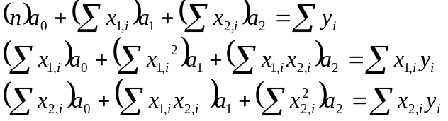

Computations for an error analysis of the quadratic least-squares fit
m=2 n=21 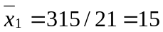 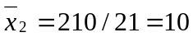
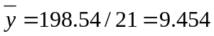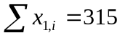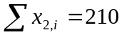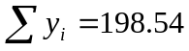
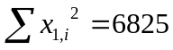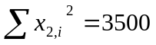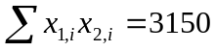
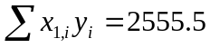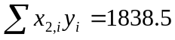
Run Matlab to solve a₀, a₁, a₂
N=[21 315 210; 315 6825 3150; 210 3150 3500];
>> r=[198.54; 2555.5; 1838.5];
>> a=N\r
a =
13.5221
-0.2012
-0.1049
Therefore, a₀= 13.5221, a₁= -0.2012, a₂= 0.1049
The least-square quadratic equation for this case is
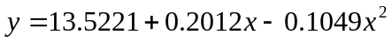
Therefore, when 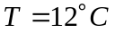 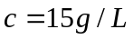
Relative approximation error 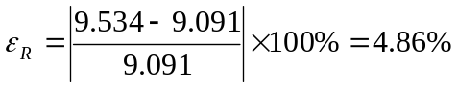
The discrepancy may be due to

14.9 Solution:
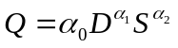
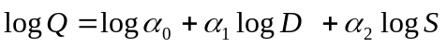
According to the following Table:
Experiment | Diameter, m | logD | Slope, m/m | logS | Flow, m³/s | logQ
1 | 0.3 | -0.52288 | 0.001 | -3 | 0.04 | -1.39794
2 | 0.6 | -0.22185 | 0.001 | -3 | 0.24 | -0.61979
3 | 0.9 | -0.04576 | 0.001 | -3 | 0.69 | -0.16115
4 | 0.3 | -0.52288 | 0.01 | -2 | 0.13 | -0.88606
5 | 0.6 | -0.22185 | 0.01 | -2 | 0.82 | -0.08619
6 | 0.9 | -0.04576 | 0.01 | -2 | 2.38 | 0.376577
7 | 0.3 | -0.52288 | 0.05 | -1.30103 | 0.31 | -0.50864
8 | 0.6 | -0.22185 | 0.05 | -1.30103 | 1.95 | 0.290035
9 | 0.9 | -0.04576 | 0.05 | -1.30103 | 5.66 | 0.752816
Least square procedure: Multiple linear regression
x_{1,i} | x_{2,i} | y_{i} | x₁² | x₂² | x₁x₂ | x₁y | x₂y | (y_{i}-)² | 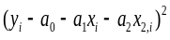
-0.52288 | -3 | -1.39794 | 0.273402 | 9 | 1.568636 | 0.730953 | 4.19382 | 1.320234 | 0.000121
-0.22185 | -3 | -0.61979 | 0.049217 | 9 | 0.665546 | 0.137499 | 1.859366 | 0.137539 | 3.67E-06
-0.04576 | -3 | -0.16115 | 0.002094 | 9 | 0.137272 | 0.007374 | 0.483453 | 0.007704 | 3.61E-05
-0.52288 | -2 | -0.88606 | 0.273402 | 4 | 1.045757 | 0.4633 | 1.772113 | 0.405936 | 7.63E-05
-0.22185 | -2 | -0.08619 | 0.049217 | 4 | 0.443697 | 0.01912 | 0.172372 | 0.026484 | 7.74E-09
-0.04576 | -2 | 0.376577 | 0.002094 | 4 | 0.091515 | -0.01723 | -0.75315 | 0.391254 | 1.4E-08
-0.52288 | -1.30103 | -0.50864 | 0.273402 | 1.692679 | 0.680281 | 0.265956 | 0.661754 | 0.067451 | 8.35E-06
-0.22185 | -1.30103 | 0.290035 | 0.049217 | 1.692679 | 0.288632 | -0.06434 | -0.37734 | 0.290478 | 2.24E-05
-0.04576 | -1.30103 | 0.752816 | 0.002094 | 1.692679 | 0.059532 | -0.03445 | -0.97944 | 1.003488 | 2.29E-05
-2.371455 | -18.9031 | -2.24033 | 0.974138 | 44.07804 | 4.98087 | 1.508181 | 7.032944 | 3.650567 | 0.00029

Computations for an error analysis of the quadratic least-squares fit
m=2 n=9 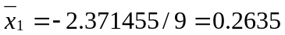 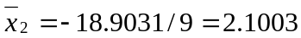
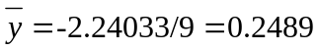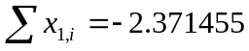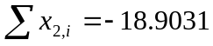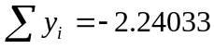
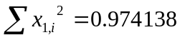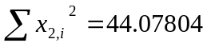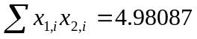
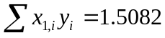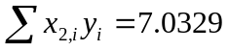

Run Matlab to solve a₀, a₁, a₂
>> N=[9 -2.3715 -18.9013; -2.3715 0.9741 4.9809; -18.9031 4.9809 44.078]
N =
9.0000 -2.3715 -18.9013
-2.3715 0.9741 4.9809
-18.9031 4.9809 44.0780
>> r=[-2.24033; 1.5082; 7.0329]
r =
-2.2403
1.5082
7.0329
>> a=N\r
a =
1.5599
2.6278
0.5316
Therefore, a₀= 1.5599, a₁= 2.6278, a₂= 0.5316 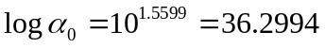
The least-square quadratic equation for this case is
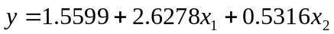
Since 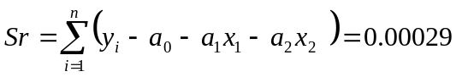
The standard error of the estimate based on the regression polynomial is
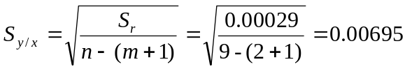
Since 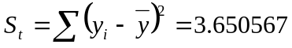
Therefore, the coefficient of determinatinon r² should be:
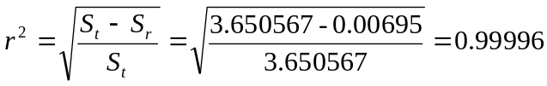 or
the correlation coefficient 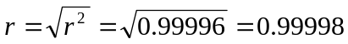
Therefore: 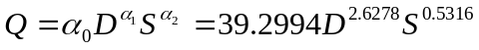

14.19 Solution:
As shown in the following table:
T(K) | K_{w} | -Log₁₀ K_{w}
0 | 1.164*10⁻¹⁵ | 14.93405
10 | 2.950*10⁻¹⁵ | 14.53018
20 | 6.846*10⁻¹⁵ | 14.16456
30 | 1.467*10⁻¹⁴ | 13.83357
40 | 2.929*10⁻¹⁴ | 13.53328
Least square procedure:

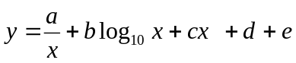

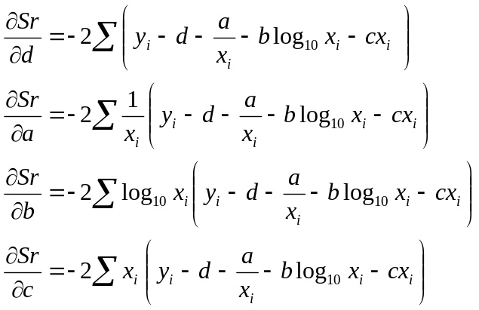
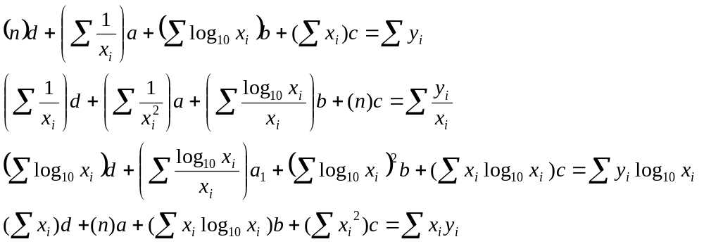
Since T=0 K, 1/T is infinitely large, thus it is not feasible to use this data:
x_{i} | y_{i} | 1/x_{i} | log₁₀x_{i} | 1/x_{i}² | log₁₀x_{i}/x_{i} | y_{i}/x_{i} | (log₁₀x_{i})² | x_{i}*log₁₀x_{i} | yi*log₁₀x_{i} | (y_{i}-)² | x_{i}*y_{i}
0 | 14.9341
10 | 14.5302 | 0.1 | 1 | 0.01 | 0.1 | 1.45 | 1 | 10 | 14.5 | 0.2552 | 145.3018
20 | 14.1646 | 0.05 | 1.3010 | 0.0025 | 0.0651 | 0.708 | 1.6927 | 26.0206 | 18.4 | 0.0195 | 283.2913
30 | 13.8336 | 0.03333 | 1.4771 | 0.0011 | 0.04924 | 0.461 | 2.1819 | 44.3136 | 20.4 | 0.0366 | 415.0071
40 | 13.5333 | 0.025 | 1.6021 | 0.00063 | 0.0401 | 0.338 | 2.5666 | 64.0824 | 21.7 | 0.2418 | 541.3312
100 | 56.1 | 0.208 | 5.38 | 0.0142 | 0.254 | 2.96 | 7.44 | 144 | 75.1 | 0.553 | 1380

Computations for an error analysis of the quadratic least-squares fit
m=2 n=4 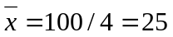 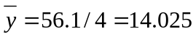
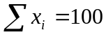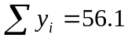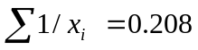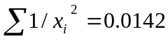
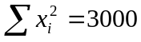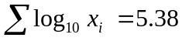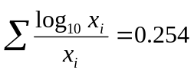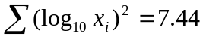
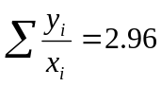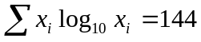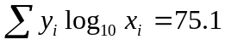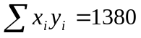
Run Matlab to solve a₀, a₁, a₂
>> N=[4 0.208 5.38 100; 0.208 0.0142 0.254 4; 5.38 0.254 7.44 144; 100 4 144 3000]
N =
1.0e+003 *
0.0040 0.0002 0.0054 0.1000
0.0002 0.0000 0.0003 0.0040
0.0054 0.0003 0.0074 0.1440
0.1000 0.0040 0.1440 3.0000
>> r=[56.1 2.96 75.1 1380]'
r =
1.0e+003 *
0.0561
0.0030
0.0751
1.3800
>> a=N\r
a =
15.8047
-15.1715
1.2005
-0.1042
Therefore, d= 15.8047, a= -15.1715, b= 1.2005, c=-0.1042
The least-square quadratic equation for this case is
